# Lesson 28 单词讲解

1. rare adj. 罕见的，稀少的

rare people

a rare disease

rare steak

生牛排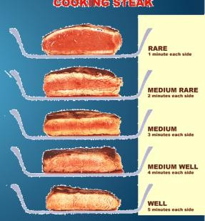

1. trouble n. 麻烦，困扰，不便，问题

have trouble with n. 关于哪件事有麻烦

have trouble (in) doing sth. 做某事有麻烦

be in trouble一直处于麻烦状态

run into trouble 变麻烦了

ask for trouble

# Lesson 28 课文&语法讲解

本课重点:

定语从句

复习现在完成时复习宾语从句

定语从句

含义：一个句子作定语，修饰限定名词位置：跟在所修饰的名词后

写法：？

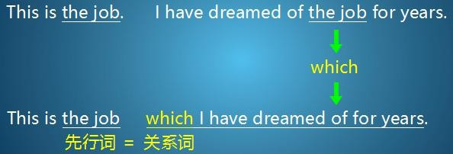定语从句的写法

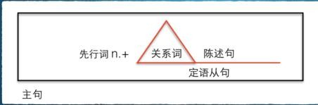

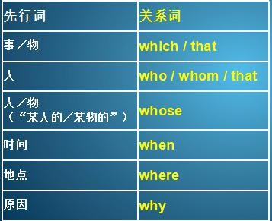

关系词的几点注意：

定语从句的关系词每一个都作成分，包括 that。whom 指人，只能在作宾语时使用。

when/where/why 引导定语从句，必须与先行词意思匹配。关系词在定语从句中作宾语时，可以省略。

1.I have a class that begins at 8:00 am. That 不可省略 因为作了主语，that带到从句里面是class begins at 8 am 所以that做了主语 ，而上面的例子 which带到从句里做了宾语所以上面句子的which可以省略 i have dreamed of the job for years

1. The lawyer who my brother called didn’t answer the phone.
2. 3.My daughter asked me a question I couldn’t answer.
3. Leo is the student whose bike was stolen.
4. Australia is one of the few countries where people drive on the left. 6.Sunday is the day when people usually don’t go to work.

7.Is there any particular reason why you can’t come?

8.I lost the book (which/that) I borrowed from the library last week.

我弄丢了上周从图书馆借的书。

1. The woman (who/that/whom) I saw in the park was feeding pigeons.

我在公园看见那位女士正在喂鸽子。

1. We like Professor Lee whose lecture is very amazing.

我们喜欢李教授,他的讲座非常精彩。

1. I cannot remember the day when we met last time.

我记不起上一次我们是什么时候碰面的。

1. Jasper White is one of those rare people who believes in ancient myths.

定语从句

who 作关系词 （引出定语从句）

one of those rare people 作先行词 （定语从句所修饰的词）

1. He has just bought a new house in the city, but ever since he moved in, he has had trouble （18 lession）with cars ...

现在完成时

1. When he returns home at night, he always finds that someone has parked a car outside his gate.

是定语从句吗？

No

1. Because of this, he has not been able to get his own car into his garage even once.

Be able to do 能够做某事

1. because of / because 接句子

her mistake, we lost the case.

she made a mistake, we lost the case.

1. Jasper has put up 'No Parking' signs outside his gate, but these have not had any effect.

Put up 放上去

1. It is one of the ugliest faces I have ever seen.

. Medusa,

the Gorgon

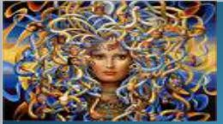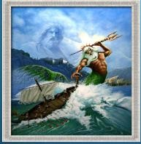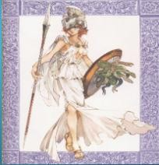

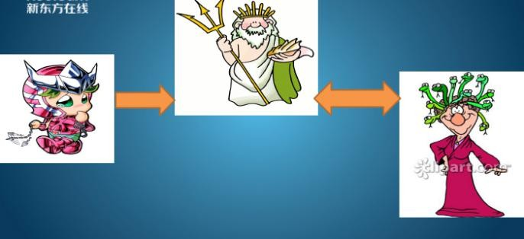

双宾语的宾语从句

1. I asked him what it was and he told me that it was Medusa, the Gorgon.

宾语从句--主谓宾

1. Jasper hopes that she will turn cars and their owners to stone.

9.But none of them has been turned to stone yet!

现在完成时的被动语态

（21lesson)

# Lesson 28 知识拓展

本课重点: 定语从句

定语从句

教过我英语的那位老师

the teacher who/that taught me English

This is the teacher who/that taught me English.

The teacher who/that taught me English is in Beijing.

定语从句

我昨天买的那本书

the book which/that I bought yesterday

I lost the book which/that I bought yesterday.

The book which/that I bought yesterday is quite interesting.

定语从句

从伦敦飞到了北京的那个乘客

the passenger who/that flew from London to Beijing

They are looking for the luggage of the passenger who/that flew from London to Beijing.

本课重点: 定语从句

